ASSIGNMENT - 17.2
D.Varshitha
2303a52317
Batch - 37
Task Description – 1(Student Academic Data Cleaning)
• Task:
Use AI assistance to generate a Python script that cleans and
prepares a student academic dataset for analysis.
Instructions:
• Handle missing values in marks, attendance, and department.
• Remove duplicate student records based on student ID.
• Standardize text fields such as department names.
• Encode categorical variables like gender and department.
Sample Code:
import pandas as pd
data = pd.read_csv("students.csv")
print(data.head())
Expected Output:
• A cleaned and encoded Pandas DataFrame suitable for academic performance analysis.

# clean student dataset: handle missing values, remove duplicates, encode categorical

Code:

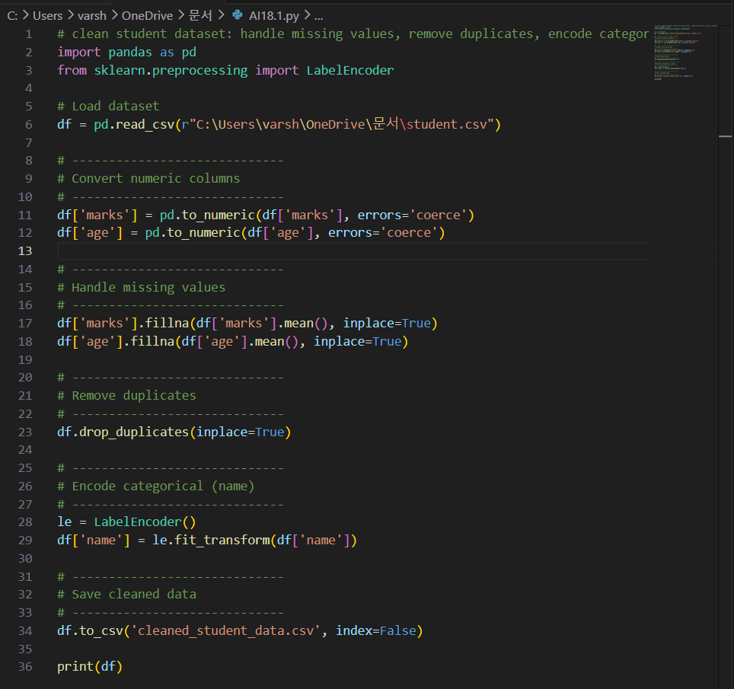

Output:
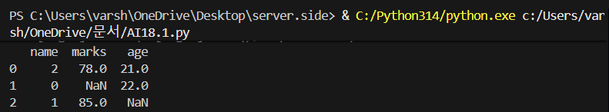

Task Description – 2 (Financial Transaction Data Preprocessing)
• Task:
Preprocess financial transaction data using AI-generated Python
code.
Instructions:
• Convert transaction date columns to datetime format.
• Create derived features such as transaction month and year.
• Normalize the transaction amount column.
• Identify and handle extreme transaction values.
Sample Code:
import pandas as pd
from sklearn.preprocessing import MinMaxScaler
transactions = pd.read_csv("transactions.csv")
print(transactions.info())
Expected Output:
• A transformed dataset with normalized values and newly
generated time-based features.

Prompt:
#Generate Python code using pandas and sklearn to preprocess a financial transactions dataset. Convert transaction_date to datetime, create month and year features, normalize transaction_amount using MinMaxScaler, handle missing values, detect and treat outliers using IQR, and save the cleaned dataset.

Code:
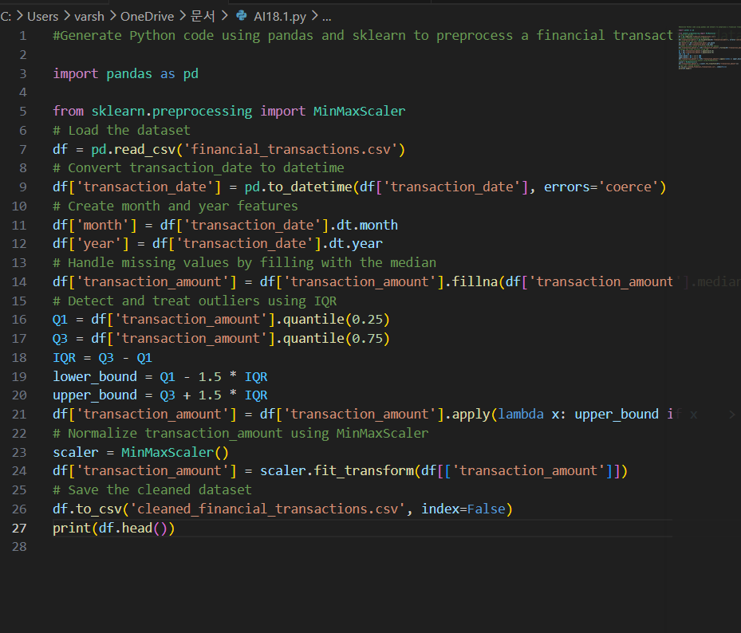

Output:

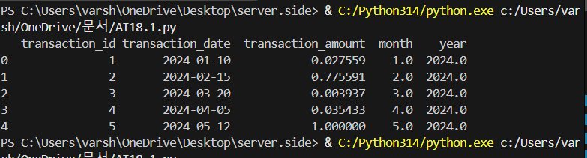
Task 3 – (Environmental Sensor Data Preparation)
• Task:
Clean and preprocess environmental sensor data using AI-assisted
scripts.
Instructions:
• Handle missing values in temperature, humidity, and
air_quality_index.
• Scale numerical features using standard scaling.
• Encode categorical fields such as sensor_status.
• Split the dataset into training and testing subsets.
Sample Code:
import pandas as pd
from sklearn.model_selection import train_test_split
data = pd.read_csv("sensor_data.csv")
Expected Output:
• A fully preprocessed dataset ready for predictive modeling tasks.
Prompt:
#Generate Python code using pandas and sklearn to preprocess an environmental sensor dataset. Handle missing values in temperature, humidity, and air_quality_index, scale numerical features using StandardScaler, encode categorical columns like sensor_status, split the dataset into training and testing sets, and save the processed data.

Code:
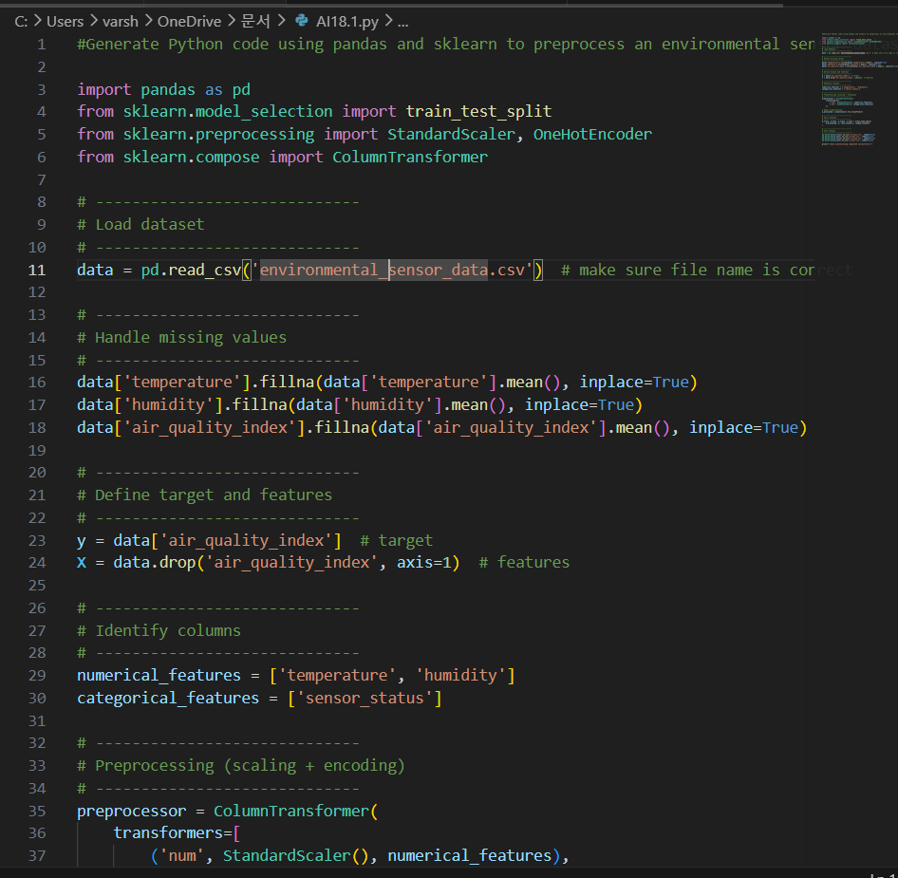

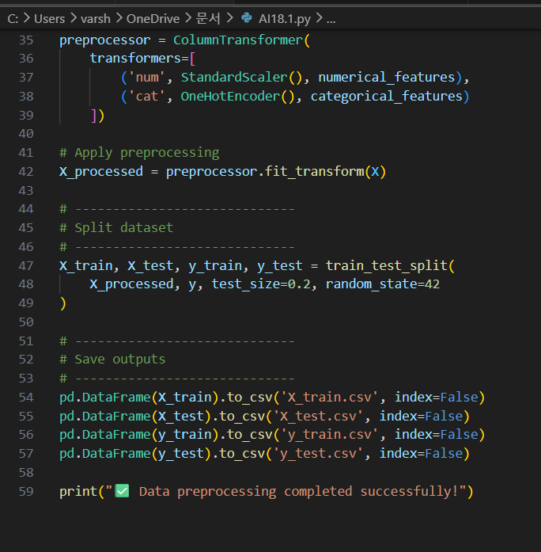

Output:
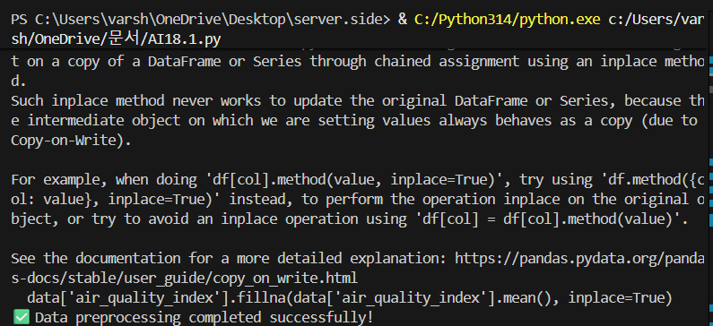
Task 4 – (Real-Time Application: Smart City Traffic Data Cleaning)
• Scenario:
A smart city system collects traffic data from multiple sensors,
resulting in noisy and inconsistent records.
Requirements:
• Standardize road and location names.
• Fill missing traffic density values using appropriate statistical
methods.
• Remove duplicate sensor readings.
• Normalize speed and vehicle count metrics.
• Generate a brief summary comparing dataset quality before and
after cleaning
Sample Code:
import pandas as pd
traffic = pd.read_csv("traffic_data.csv")
print(traffic.describe())
Expected Output:
• A cleaned and normalized traffic dataset with an accompanying
data-quality improvement summary.

Prompt:
#Generate Python code using pandas and sklearn to clean a traffic dataset. Standardize road and location names, fill missing traffic_density values, remove duplicates, normalize speed and vehicle_count, and print a before vs after data quality summary.

Code:
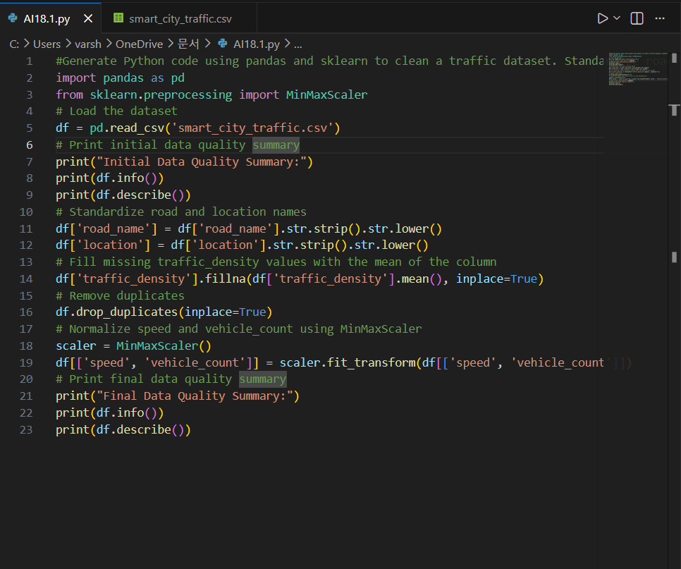
Output:
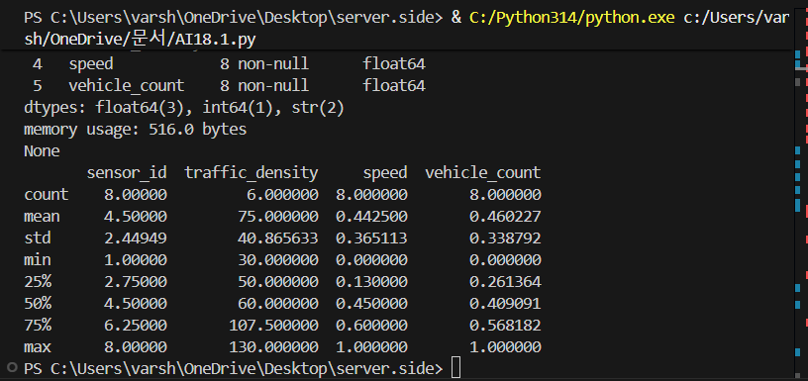

Task 5 – (Social Media Text Data Cleaning and Feature Extraction)
• Task:
Use AI-assisted Python scripting to clean and preprocess social
media text data for sentiment analysis.
Instructions:
• Remove duplicate posts and null text entries.
• Clean text by removing URLs, special characters, and extra
spaces.
• Convert text to lowercase and perform basic tokenization.
• Remove stopwords and perform stemming or lemmatization.
• Generate basic text features such as word count and sentiment
score.
Sample Code:
import pandas as pd
import re
posts = pd.read_csv("social_media_posts.csv")
print(posts.head())
Expected Output:
A cleaned text dataset with extracted features suitable for sentiment
analysis models.
Note: Report should be submitted a word document for all tasks in a
single document with prompts, comments & code explanation, and
output and if required, screenshots.

Prompt:
#Generate Python code using pandas, re, and nltk to preprocess social media text data. Remove duplicate and null posts, clean text by removing URLs and special characters, convert to lowercase, tokenize text, remove stopwords, perform stemming or lemmatization, and create features like word count and sentiment score. Save the cleaned dataset.

Code:
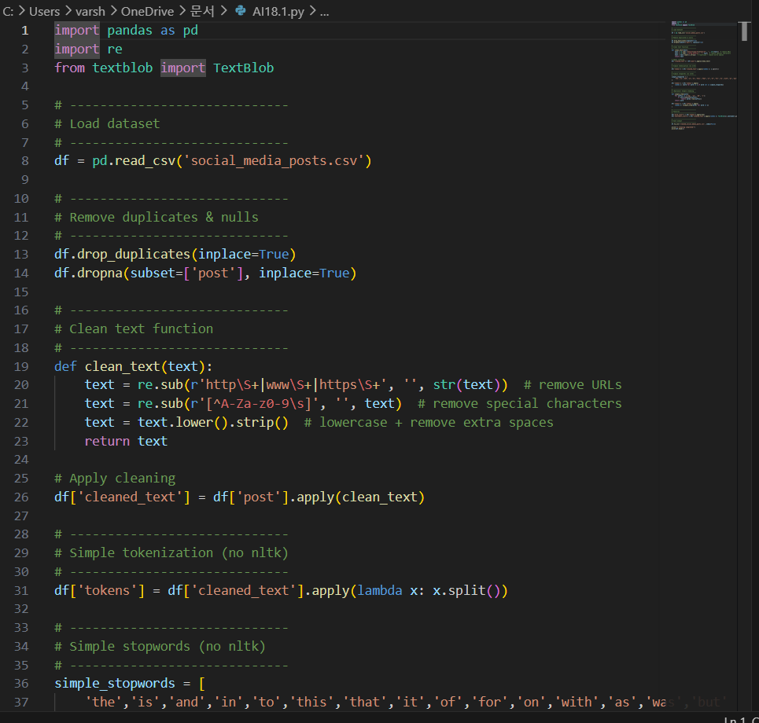
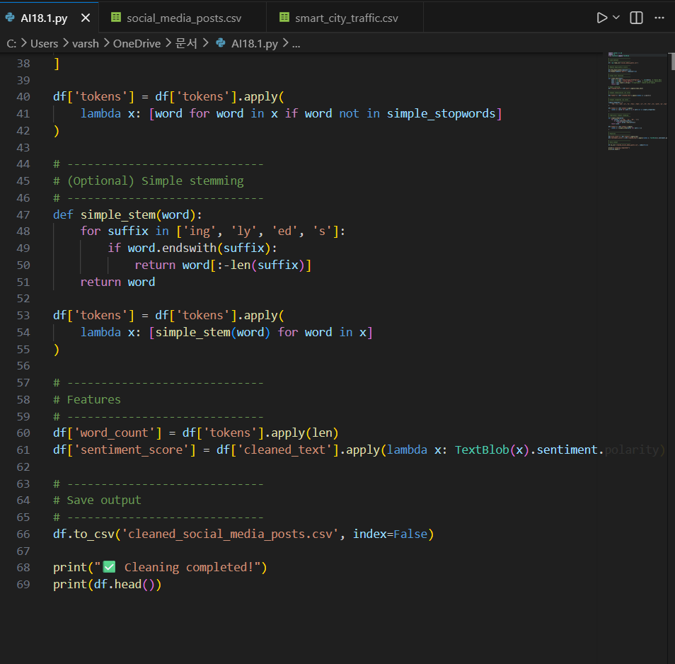
Output:
